**EIT RawMaterials supported project developed prototype of ultra-fine grinding mill**

**News 19/12/2019**

[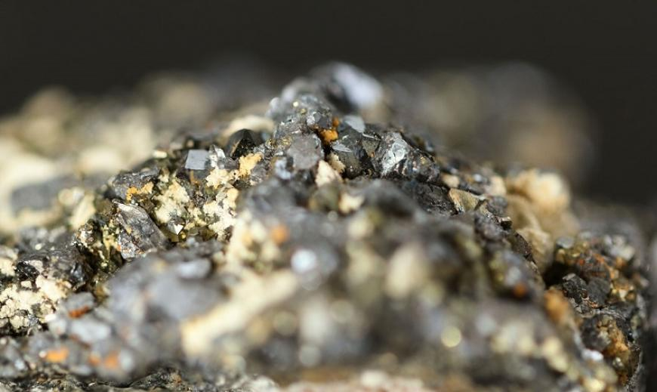](https://eit.europa.eu/sites/default/files/raw-natural-polymetallic-ore-with-pyrite-chalcopyrite-galena-and-sphalerite.jpg)

**EIT RawMaterials supported RoStar project developed a prototype of an ultra-fine grinding mill.**

It liberates more ores and consumes less energy.

**Less energy consumption**

The mill is a prototype of a new ultra-fine grinding mill for the liberation of high-value particles met in platinum-group metals containing ores, copper ores or other polymetallic ores with fine dissemination of mineral phases.

*This mill consumes 20-30% less energy compared to similar established mills and increases ore liberation with at least 20% less locked ore at same particle size.*

*Professor Urs Peuker at Technische Universität Bergakademie Freiberg and leader of the RoStar project*

The RoStar prototype has proven to increase the operation period with 50% before maintenance is needed. Additionally, the maintenance itself is 50% faster compared to similarly established mills, due to an optimised rotor-stator geometry and improved wear resistance through a modular construction of the mill housing.

*The RoStar mill offers an answer to the forthcoming challenges already seen in fine milling trends. Tangible applications are opened in re-grinding-flotation circuits, tailings re-processing as well as in enabling access to future deposits containing valuable or critical materials.*

*Professor Peuker*

The mill will be a vertical fine grinding mill, where gravity forces enable a higher filling level than in horizontal mills and a hydraulic pressure on the grinding beads. The new improved design of the Mills Rotor/Stator system was launched into the market in the year 2018.

Deliverables of the RoStar innovation project will be a containerised pilot plant, a fine milling process with very low energy consumption. A flexible and mobile unit is set up and followed by a demonstration and proving of mill performance in a real industrial environment, the testing takes place at Assarel-Medet (SME) plant site in Bulgaria.

RoStar project partnership:

* Technische Universität Bergakademie Freiberg (TUBAF), Germany (Lead Partner)
* Agencia Estatal Consejo Superior de Investigaciones Cientificas, CSIC (Spanish National Research Council), Spain
* Assarel Medet, Bulgaria
* CEMTEC, Austria
* Maelgwyn Mineral Services Limited, United Kingdom
* Sandvik AB, Sweden
* Sandvik SRP AB, Sweden
* Université de Liège, Belgium